Digital Pirani Vacuum Gauge DPRG-2GH (decimal display)
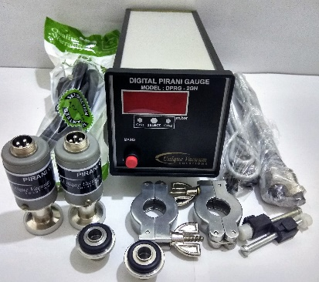
The UVS Model DPRG series Vacuum Pirani Gauge Controller displays vacuum pressure as measured from a S-PR-GH sensor tube. It displays vacuum measurements based on thermal conductivity of gases. The Model DPRG-2GH unit covers the range from 0.001mbar to 20 mbar, and measures two channels simultaneously. The display channel selection through membrane switch on the front bezel.

TECHNICAL SPECIFICATIONS
Number of sensor channels | TWO
Display Range | 1000 mBar to 0.001mBar.
Measuring Range | 20 mBar to 0.001mBar.
Units of Display | m.Bar
Vacuum Gauge Head | S-PR-GH sensor tube
Channel selection | Through selection switch provided on the front panel
Temp. Range | +2 to +50 deg. Celsius
VAC. Display | 4-digit bright red LED, 14 mm high
VAC and ATM Adjust | adjusted by trim pot at the signal conditioner PCB.
Operating Voltage | universal power supply, input voltages from 90 ~ 264VAC 50/60 Hz
Mounting | ¼ DIN 92 x 92 mm (3.62” x 3.62")
Environmental Considerations | not for use with explosive or corrosive gases
Overall dimensions | 92mm X 92mm X 110mm Depth
Optional outputs on request | RS485, 0 -10V Dc analog output
Features at a Glance
■ Measurement range 0.001 to 20 mbar ■ Space saving rugged design- 1/8 DIN console ■ Space saving rugged design- 1/8 DIN console ■ Mounts in any orientation ■ brass body measuring cell with metal-sealed feed through ■ with universal power supply – input voltage from 90 ~ 264VAC, frequency 47 ~ 440Hz
Applications
■ Controlling high vacuum systems ■ Fore vacuum pressure monitoring ■ Safety circuits in vacuum systems ■ General vacuum measurement & control in the fine and rough vacuum range.
Calibration:
Unique Vacuum Solutions offers a convenient recalibration service to help users of vacuum measurement pirani/ thermocouple/ full range gauges to maintain all of their vacuum gauges in Certified and peak condition, regardless of the original manufacturer. All makes of vacuum gauges can also be calibrated / repaired if required.
The calibration certificates are available only on request at additional cost. Pl contact before ordering.

UNIQUE VACUUM SOLUTIONS
#57, 8th cross, 1st B cross, Daddanna industrial area main raod, vishwaneedam post, Near Peenya 2nd stage, Bangalore -560091
Ph: 080-28367059, 9886726920. e mail: support@uniquevacuum.co.in, WEB: www.uniquevacuum.co.in

